UNITED STATES
SECURITIES AND EXCHANGE COMMISSION
WASHINGTON, D.C. 20549

Schedule 14A Information

Proxy Statement Pursuant to Section 14(a) of the Securities Exchange Act of 1934

Filed by the Registrant ☒ | Filed by a Party other than the Registrant ☐

Check the appropriate box:

☐ | Preliminary Proxy Statement
☐ | Confidential, for Use of the Commission Only (as permitted by Rule 14a-6(e)(2))
☐ | Definitive Proxy Statement
☒ | Definitive Additional Materials
☐ | Soliciting Material Pursuant to §240.14a-12

Lineage Cell Therapeutics, Inc.
(Name of Registrant as Specified in Its Charter)
(Name of Person(s) Filing Proxy Statement if other than the Registrant)
Payment of Filing Fee (Check the appropriate box):

☒ | No fee required.
☐ | Fee paid previously with preliminary materials.
☐ | Fee computed on table in exhibit required by Item 25(b) per Exchange Act Rules 14a-6(i)(1) and 0-11

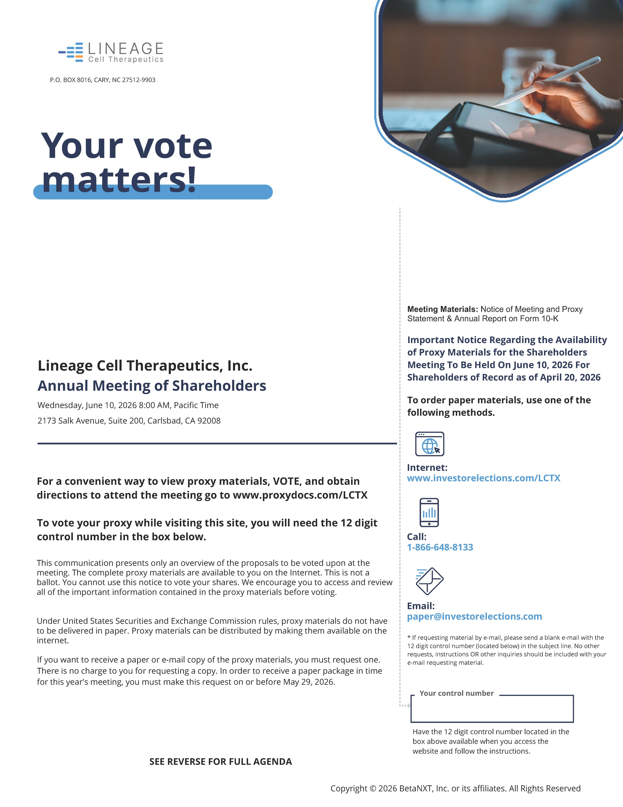

P.O. BOX 8016, CARY, NC 27512-9903 Your vote matters! Lineage Cell Therapeutics, Inc. Annual Meeting of Shareholders Wednesday, June 10, 2026 8:00 AM, Pacific Time 2173 Salk Avenue, Suite 200, Carlsbad, CA 92008 styleINA Meeting Materials: Notice of Meeting and Proxy Statement & Annual Report on Form 10-K Important Notice Regarding the Availability of Proxy Materials for the Shareholders Meeting To Be Held On June 10, 2026 For Shareholders of Record as of April 20, 2026 To order paper materials, use one of the following methods. For a convenient way to view proxy materials, VOTE, and obtain directions to attend the meeting go to www.proxydocs.com/LCTX To vote your proxy while visiting this site, you will need the 12 digit control number in the box below. This communication presents only an overview of the proposals to be voted upon at the meeting. The complete proxy materials are available to you on the Internet. This is not a ballot. You cannot use this notice to vote your shares. We encourage you to access and review all of the important information contained in the proxy materials before voting. Under United States Securities and Exchange Commission rules, proxy materials do not have to be delivered in paper. Proxy materials can be distributed by making them available on the internet. If you want to receive a paper or e-mail copy of the proxy materials, you must request one. There is no charge to you for requesting a copy. In order to receive a paper package in time for this year's meeting, you must make this request on or before May 29, 2026. Internet: www.investorelections.com/LCTX Call: 1-866-648-8133 Email: paper@investorelections.com * If requesting material by e-mail, please send a blank e-mail with the 12 digit control number (located below) in the subject line. No other requests, instructions OR other inquiries should be included with your e-mail requesting material. Your control number Have the 12 digit control number located in the box above available when you access the website and follow the instructions. SEE REVERSE FOR FULL AGENDA Copyright © 2026 BetaNXT, Inc. or its affiliates. All Rights Reserved

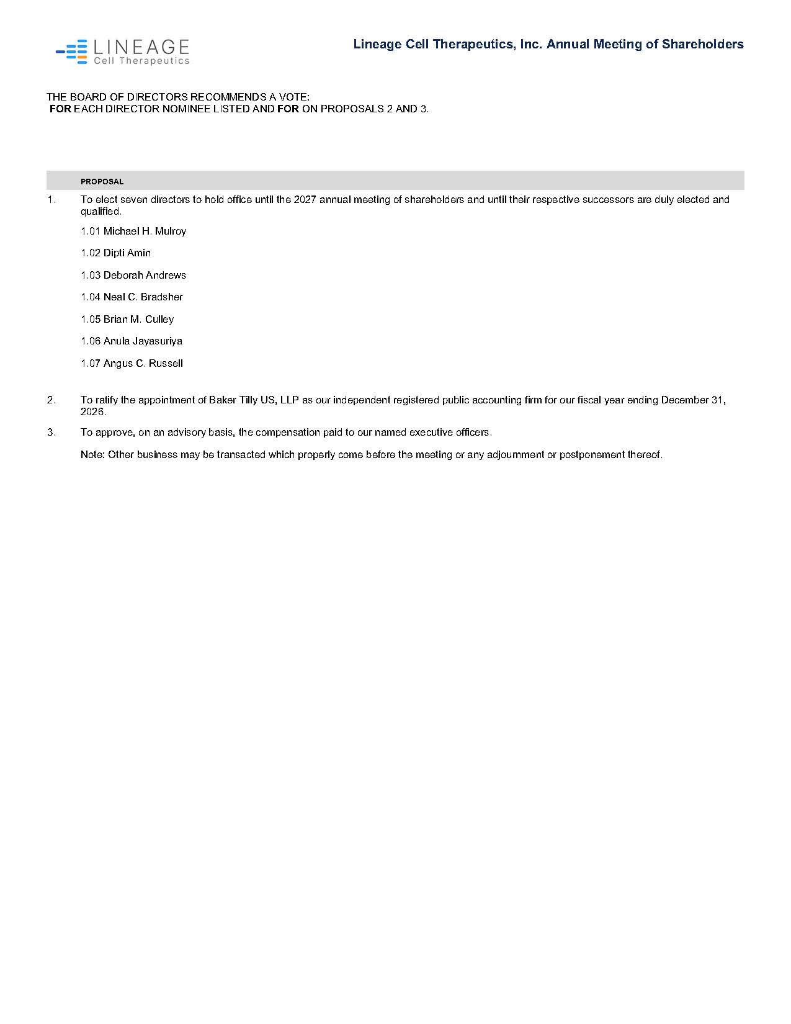

Lineage Cell Therapeutics, Inc. Annual Meeting of Shareholders THE BOARD OF DIRECTORS RECOMMENDS A VOTE: FOR EACH DIRECTOR NOMINEE LISTED AND FOR ON PROPOSALS 2 AND 3. PROPOSAL 1. To elect seven directors to hold office until the 2027 annual meeting of shareholders and until their respective successors are duly elected and qualified. 1.01 Michael H. Mulroy 1.02 Dipti Amin 1.03 Deborah Andrews 1.04 Neal C. Bradsher 1.05 Brian M. Culley 1.06 Anula Jayasuriya 1.07 Angus C. Russell 2. To ratify the appointment of Baker Tilly US, LLP as our independent registered public accounting firm for our fiscal year ending December 31, 2026. 3. To approve, on an advisory basis, the compensation paid to our named executive officers. Note: Other business may be transacted which properly come before the meeting or any adjournment or postponement thereof.

